*You are the voice of many small subsistence levels farmers in developing nations. The vast majority of you are women with several small children to feed. May of you are not entitled to the same access to land, credit, and fertilizers as men. You have little to no voice in government decisions. All you want is to have enough food to feed your family all year round and a little extra money.*

**Background Information:**

* In developing countries, small farms could be far more productive than they are now.
* 50-90% of the population in developing nations engage in farming of some kind.
* Africa has the largest “yield gap,” producing the same amount of wheat in a single year as the Romans did under Julius Caesar. This is due to poor infrastructure, limited markets, weak governments, civil wars, and increased urbanization.
* Agricultural production varies by country. In example, Thailand exports more food than all of Sub-Saharan Africa combined.
* Operational costs also vary greatly by country. For instance, one of the biggest issues is Africans pay 82% more for fertilizer than other countries, plus pay higher taxes and bribes to operate.
* Costs are starting to change a little with decreasing national debts, increase in peaceful elections, an increase in technology available, and greater involvement of the World Bank, donor countries, and large corporations.
* Government officials believe that large, foreign-owned farms are more productive and beneficial for the country, so they give large land grants and policy “breaks” to these large companies.
* Most of these large companies move in and displace the small farmer, hire very few of them to work often at below poverty wages, and then exploit the workers. The companies deal only with the government, not the local people.
* Many small farmers see medium sized farms and large—locally owned— farms being more economical and prosperous, as well as being better for the local people.
* Local farms provide local food, monetary resources, and pride for the people. Locally owned large farms bring in key resources and employment. The key practice and message to large companies—keep your promises!

**Vocabulary**

*subsistence farming: subsistence farming*: typically a small-scale farming operation in which farmers focus on growing enough food to feed themselves and their families.

*infrastructure:* the basic physical and organizational structures and facilities (e.g., buildings, roads, and power supplies) needed for the operation of a society or enterprise.

*urbanization:* the increasing number of people that live in urban areas. It predominantly results in the physical growth of urban areas, be it horizontal or vertical. The United Nations projected that half of the world's population would live in urban areas at the end of 2008.

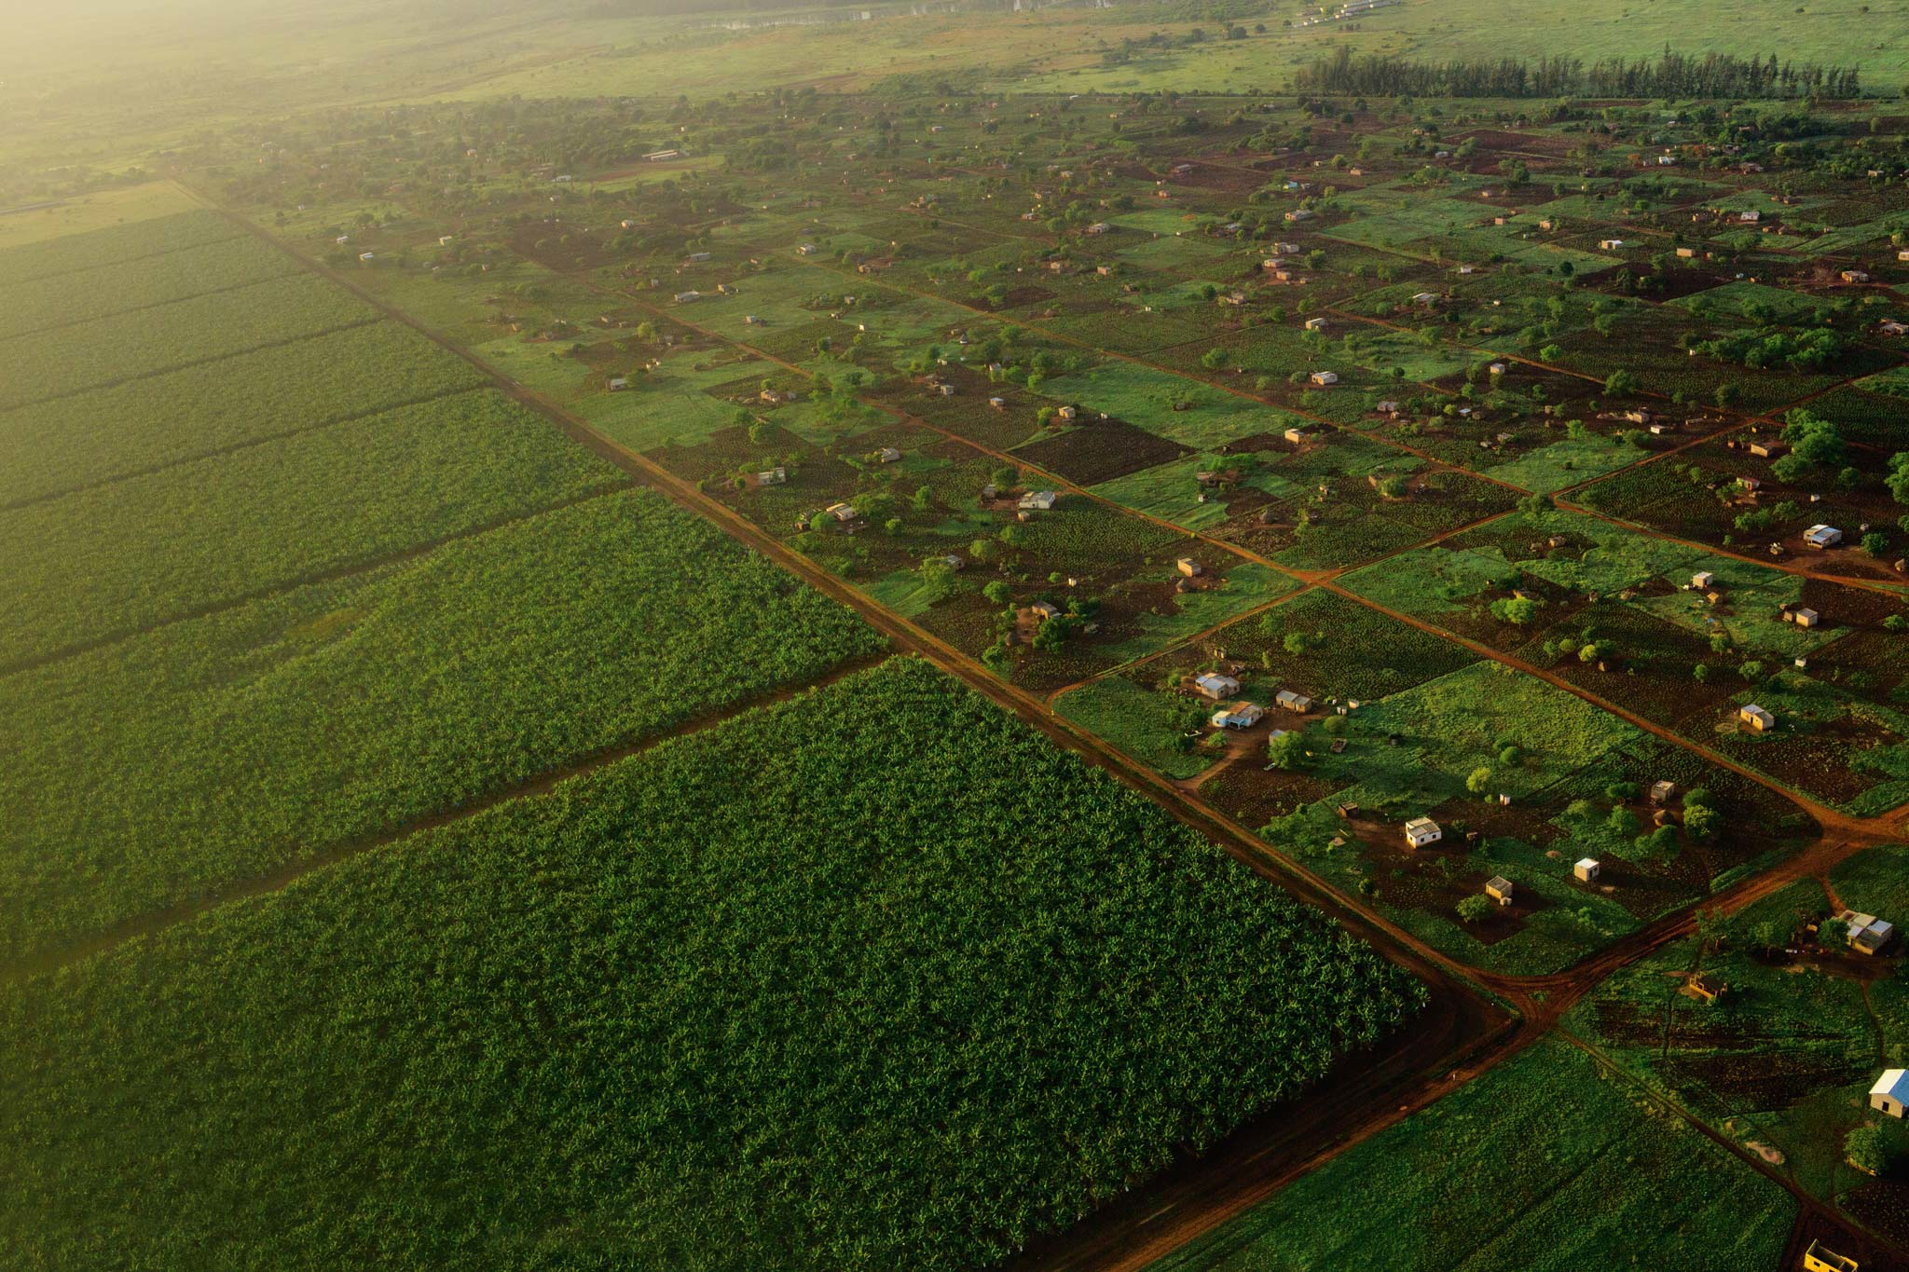

<http://www.nationalgeographic.com/foodfeatures/land-grab/images/img2_2048.jpg>